2021 Kossuth County
Fair Pageant

Entry Deadline
July 5th.
If entries are received after July 5th contestant photos will not be included in the newspaper or pageant programs.
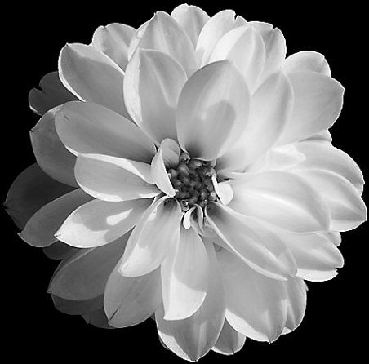

Tuesday, August 3rd

Kossuth County Fair Grandstand- 8:00pm
** $500 Cash **
Awarded to the
2021 Fair Queen
& $50 Cash Prizes Awarded to all 2021 Fair Royalty
Sponsored by

Contestant interviews will take place Sunday, August 1st.

More information will be sent to contestants.
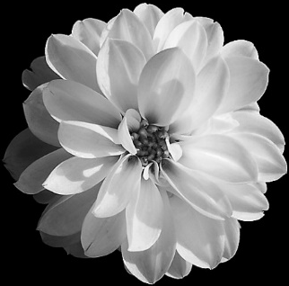
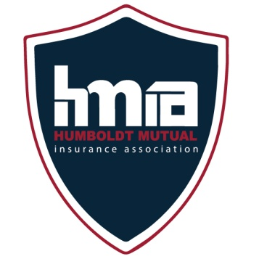
Queen…17-21 years old
Jr. Miss…14-16 years old
Princess…11-13 years old
Lil’ Miss…8-10 years old
Lil’ Princess…5-7 years old

Great gifts for everyone that participates!!
** $500 Scholarship **
Awarded to the 2021 Fair Queen

Sponsored by
Humboldt Mutual
Insurance

Download Entry Form at kossuthcountyfair.com or
Pick up Entry Form at the
Kossuth County Extension Office.
Please call Morgan if any questions,
341-2289 or email mlmuller24@gmail.com

Kossuth County Fair Lil’ Princess
Age 5-7

Name: ______________________________________________________________________________________________
Address:______________________________________Town:______________________ Zip:____________________
Birthdate:_______________________________ Age (As of July 28th):________________________________
School:____________________________________________________________ Grade:_________________________
Parents:_____________________________________________________________________________________________
Siblings:_____________________________________________________________________________________________

What would you like to be when you grow up?___________________________________________________ ___________________________________________________________________________________________________________
Pets:_________________________________________________________________________________________________________________________________________________________________________________________________________________
Activities/Community Involvement:_________________________________________________________________
____________________________________________________________________________________________________________________________________________________________________________________________________________________________________________________________________________________________________________________________________________________________________________________________________________________________________________
Interesting Facts/Favorite things to do:____________________________________________________________
____________________________________________________________________________________________________________________________________________________________________________________________________________________________________________________________________________________________________________________________________________________________________________________________________________________________________________

Please enclose a 4x6 or smaller photo.

*Each contestant will receive a t-shirt. Please indicate size.
YXS(2-4) YS(6-8) YM(10-12) YL(14-16) YXL(18-20) OR ADULT___________

Parent E-Mail Address: ________________________________ Phone Number:________________

Mail entry form to:
Kossuth County Ag Association
PO Box 362,
Algona, IA 50511

Entry Deadline: July 5th.

Rules and Information for Entering
the 2021 Kossuth County Fair Pageant

- The 20121 Fair Lil’ Princess is expected to attend each day of the Kossuth County Fair, August 3rd-August 7th. Fair Royalty will hand out ribbons and trophies at various events during the fair. If you are not able to attend the Kossuth County Fair, please do not enter.

- The Fair Royalty will represent the Kossuth County Fair in parades and other various events throughout the year.

- The 2021 Fair Royalty will be invited back to the 2022 Kossuth County Fair Pageant to help crown the new Fair Royalty.

- Contestant Interviews will be held on Sunday, August 1st. Contestants will have a personal interview with a panel of three judges. The location and interview times will be sent to contestants at a later date.

- Contestants should wear nice clothes for their interview (skirt, dress, dress pants, etc., no blue jeans).

- Lil’ Princess Contestants will introduce themselves on stage. Introductions will include name, age, and parents. We will practice introductions on Sunday during interviews.

- Contestants are invited to ride in the Kossuth County Fair Parade on Tuesday, August 3rd at 6:00pm. Contestants will meet at 5:40pm in the Algona Publishing parking lot.

